167 Parry St,
Hamilton East,
NSW, 2303
(02) 49625316
hcec.org.au

We are grateful for the opportunity to make a submission to the Chain Valley Colliery Consolidation Project (SSD-17017460). We oppose the Project due to the EIS being inadequate to properly evaluate the likely impacts.
Table of Contents
Introduction 1
Subsidence 2
Seagrass 3
Conclusion 6

Introduction
Chain Valley Colliery Consolidation Project (SSD-17017460) seeks to consolidate the Chain Valley and Mannering Collieries and extend mining from 2027 to 2029 at reduced capacity, to align the life of mining operations with the planned operational period of the Vales Point power station.
The Chain Valley Extension Project (SSD-5465) was approved in 2013, the fourth modification to which allowed a boundary change to the Chain Valley Colliery lease to mine beneath the suburbs of Brightwaters, Mirrabooka and Sunshine. This Northern Mining Area of 117 hectare, purchased by Delta Coal in 2019 from Centennial’s Myuna Colliery, is now proposed to be mined.
Delta Coal can currently extract and transport up to 3.2 million tonnes per annum of run-of-mine coal from the Chain Valley Colliery and Mannering Colliery until December 31, 2027. While the Consolidation Project proposes increasing the area mined, it will reduce annual coal extraction to 2.8 million tonnes of run-of-mine coal. We estimate the annual coal consumption of the Vales Point power station, owned by Delta Coal’s parent company Sunset Power International Pty Ltd, is about 2.65 million tonnes - at a plant load factor of 63.75% (7,372 GW·h/pa).
The extension to the term of the mining to 2029 will also be made possible by secondary extraction below Lake Macquarie, which entails mining the support pillars left after past mining operations. The maximum predicted subsidence of the Lake bed due to this secondary extraction is 780mm. However, this is in addition to the subsidence to that has already been experienced, which appears to be up to 1.2m. Nowhere in the EIS have they described or assessed the impacts such lakebed subsidence has on benthic communities.
Many times does the EIS restate that this Project would align the life of mining operations with the planned operational period of the Vales Point power station. The two Collieries and the Vales Point power station are intimately connected. All these operations are owned by Sunset Power International Pty Ltd, and the mines underpin the sale of Delta Electricity to Sev.en Global Investments Pty Ltd. If these mines were not given consent to continue to undermine Lake Macquarie and surrounding suburbs until 2029, the Vales Point power station would cease operating in 2027.

The ‘likely impacts’ of the project logically includes the likely environmental, social, and economic impacts of Vales Point power station operating from 2027 to 2029, together with the likely impacts associated with Chain Valley and Mannering Collieries.

The EIS fails to properly evaluate the likely impacts of the proposal and is inadequate to determine the merits of proposal. The Chain Valley Colliery Consolidation project must be therefore be rejected.

Subsidence
The presence of underground coal mining has defined the development and urban regeneration of the region. The form of settlements and their location aboveground has been mediated by the presence of underground mine shafts and the cost of grouting them. However, little inquiry is evident into the subsidence impacts caused by coal mining to the lakebed of Lake Macquarie.
Subsidence associated with underground coal mining in the area has caused obvious significant damage to buildings and the terrestrial environment. The EIS points to “unplanned subsidence” in 1987 affecting Chain Valley Bay South and Chain Valley Bay North (Teragalin Drive and Foreshore) associated with mining that involved pillar extraction within the Great Northern Seam at Newvale Colliery. Subsidence impacts to surface infrastructure and natural features were significant. The subsidence apparently ruined the wetland and damaged homes and infrastructure. Previous coal mining damage at Chain Valley Bay includes subsidence of Karignan Creek causing a rise in water level, killing thousands of native trees.
Parts of the suburbs of Mannering Park (pop. 2,600), Chain Valley Bay (pop. 2,500), Morisset Park (pop.3,200), and Wyee Point (pop.1,200) have already been undermined for coal, and this Project proposes to undermine parts of Mirrabooka (pop. 728), Sunshine (pop. 550), and Brightwater (pop. 900). The Morisset Hospital, and the entire Vales Point power station ash dam have also been undermined.

The EIS states that mining to the east and south in the Great Northern Seam was investigated and the ‘Eastern Mining Area’ (beneath Chain Valley Bay North) was initially pursued as part of the Consolidated Project. Mining into this area would have involved mining under fewer residences and less infrastructure than would occur if mining were to progress to the north-west into unmined areas within the Delta Coal mining lease holdings.

Delta is no longer pursuing approval to mine the Eastern Mining Area beneath the suburb of Chain Valley Bay North, some of which has previously been undermined, as the western and north-western area has not been undermined in any other seams, and will provide sufficient resources to satisfy the likely demand for coal to the end of 2029. However, Delta Coal is continuing to investigate the potential extension of mining to the north, east and south-east of the Project mining areas should there be a need to continue supply to Vales Point power station beyond 2029.

Seagrass
The Biodiversity Assessment points to annual seagrass surveys since 2020 having “discovered large and unexplained changes in seagrass cover”. The Assessment suggests this is unrelated to underground coal mining, as mining had not impacted seagrass beds since commencement of monitoring. This adds nothing to our understanding of likely cumulative impacts to seagrass beds and possible disturbance to the complex relationships between and within benthic communities, which may be disrupted by the Project.
Seagrasses are flowering plants that photosynthesise, making them sensitive to mine subsidence. Subsidence lowers the lakebed and reduces the amount of light penetration as it increases the water depth. Nutrient input and turbidity of the Lake have compounding effects.
Benthic (bottom) communities such as seagrass beds are key to the survival of juvenile fishes due to the refuge they provide from predators. Subsidence can affect benthic communities by increasing the depth of the lakebed and decreasing the light penetration of the water column. It also affects light dependent biota, such as algae and biofilms, on which benthic organisms such as molluscs, annelid worms, and crustaceans feed.
One of the “Key Findings” of the EIS is “Due to the commitment to negligible levels of subsidence below land areas and seagrass beds, indirect impacts associated with the Project are predicted to be negligible, therefore no biodiversity offsets are required.”
The EIS points to the “Seagrass Protection Barrier (SPB)” as protecting seagrass from subsidence, which together with the “High Water Mark Subsidence Barrier (HWMSB)” forms Zone A suggested to be subject of a maximum of 20 mm subsidence, rather than the maximum 780 mm for Zone B, which is beneath the deeper water of southern Lake Macquarie.
However, an assessment of the relationships between the extent of seagrass, subsidence, and potential cumulative impacts of operating Vales Point power station and the Collieries operated by Delta Coal, is lacking.
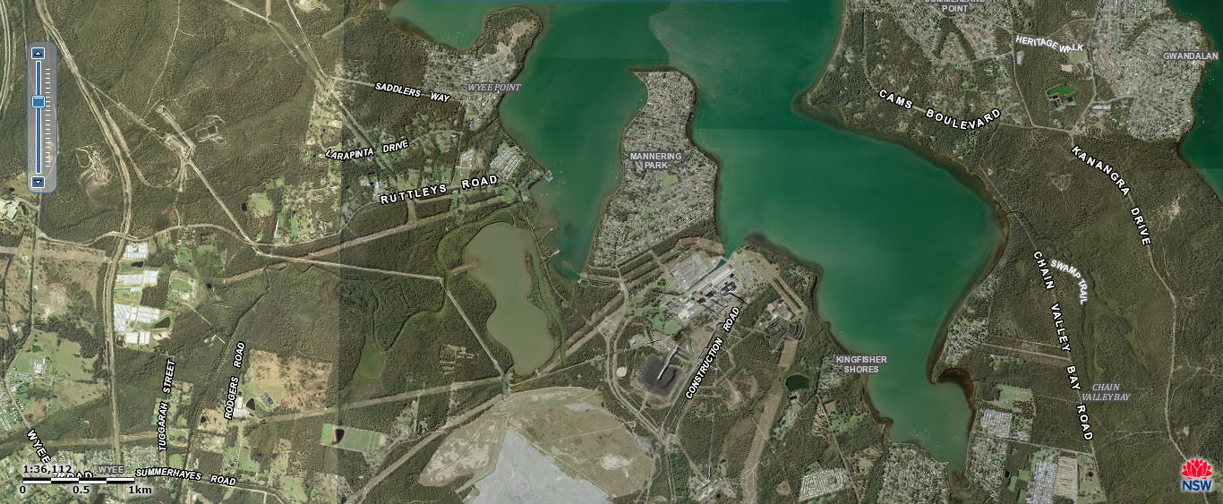
SIX maps image showing Vales Point power station (centre), Wyee Bay (left), CVC pit mouth (near Kingfisher Shores) and Chain Valley Bay right. Vales Point ash dam (centre bottom).
Lake water is drawn into the Vales Point power station to operate the cooling-water condensers via an intake canal on the western shore of Chain Valley Bay. The cooling water is returned to the lake via an open canal at a point close to the southern-most end and on the eastern shore of Wyee Bay at a maximum temperatures of 35.5º C and a mean flow of 4.32 GL a day. The maximum EPL discharge volume is set at 6.5GL/day. Such flow could have considerable impact on water temperatures and turbidity outside of Wyee Bay.
Seagrass in Wyee Bay has all but disappeared due to excessive thermal pollution from the Vales Point power station. Increased water temperatures and flow from Vales Point’s discharge has been known to influence temperatures at the Vales Point intakes in Chain Valley Bay. However, no assessment is evident in the EIS to determine whether this increased temperatures is affecting seagrass beds in Chain Valley Bay, or indeed having a cumulative effect on seagrasses.
Since 1995, water has been removed from the Vales Point ash dam and recycled back to the power station, where it is mixed with cooling water before being discharged into Wyee Bay. The new procedures were expected to raise selenium concentrations within the ash dam but reduce the amount of suspended and dissolved trace metals reaching the lake. However, this has not always been successful and Delta Electricity have been in breach of EPL conditions a number of times for excessive TSS concentrations in its discharge.
The Vales Point power station is the potential cause of significant turbidity, which is often high in the waters of southern Lake Macquarie. Yet the EIS does not explore these interaction and potential cumulative impacts of lower light availability and subsidence, and whether this has any appreciable impact on the extant area of seagrass, or whether an accumulation of stressors, including turbidity thermal pollution, hypo-salinity, and subsidence could be impacting seagrass beds.
Indeed, no assessment is provided in the EIS of the potential impact on Lake Macquarie from the proponent’s own discharge. The 2013, Assessment Report for Chain Valley Colliery Modification to Mining Extension 1 (SSD 5465 Mod 2) states the median annual groundwater inflow to the Fassifern Seam workings at Chain Valley was 2,440 mega lites (ML) and was predicted to increase to 3,832 ML. The volume licenced is 4,443 ML/yr.
The EIS suggests total groundwater inflows to CVC between 2018 and 2022 averaged 6.7 ML/day (2,445 ML/pa). However, total groundwater inflow to CVC in 2019 was 3,129 ML. On an annual basis, average groundwater inflow to the Fassifern Seam ranged from 0.5 ML/day in 2019 to 1.4 ML/day in 2020. The EIS points out that the increase in groundwater inflow from 2019 to 2020 of 0.9 ML/day may be attributable to secondary extraction.
The EIS states that groundwater inflow is brackish to saline in subsided areas of the Great Northern Seam workings (11,800–28,200 mg/L). However, seepage from a dyke at the northern end of the current Fassifern Seam workings was reported to have brackish salinity (2,390 mg/L) and a pH of 8.63, indicating an absence of hydraulic connection between Lake Macquarie and the Fassifern Seam. Indeed, EPL monitoring by Delta Coal shows some discharge with very low salinity. For example, 7 July 2022 EPL monitoring results show discharge of 2.4ML with an EC of 302 us/cm (142 mg/L salinity). A level that may cause seagrass beds to die-back.
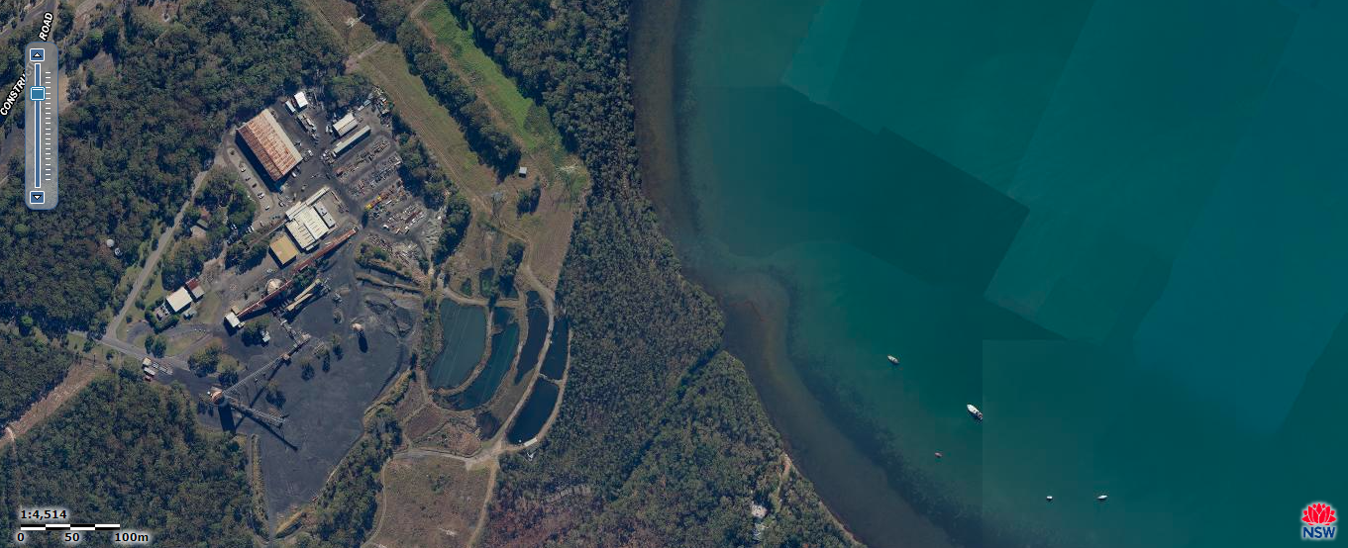
CVC pit mouth, discharge settlement ponds, and Swindles Creek mine discharge.
Seagrasses are seasonally exposed to low salinity events during catchment runoff which exposes them to osmotic shock. Halophila ovalis and Zostera muelleri has been demonstrated to show stress responses to salinity ranging from 3 to 36 PSU (~103 mg/L -1,224 mg/L at 25ºC). Optimum salinity was found by Collier et al (2014) to be above 36 PSU (1,224 mg/L at 25ºC) with osmotic stress appearing as small increases in shoot density at 27–33 PSU (~920 mg/L -1130 mg/L at 25ºC). Zostera muelleri was found to survive to salinities as low as 3 PSU (102.6mg/L at 25ºC), while Halophila ovalis remained abundant at 9 PSU (308 mg/L at 25ºC).
The study demonstrates that seed production in these species was inhibited by chronic exposure to hypo-salinity. These authors point out that even If seed production and germination is successful, seedling development is highly sensitive to small changes in salinity. Increased shoot density of Zostera and Halophila in response to severe osmotic shock could suggest that the population is healthy and increasing in abundance, while in fact under significant stress and unable to sexually reproduce.
Seagrass in Chain Valley Bay appears to be regularly exposed to unnatural hypo-saline conditions resulting from the discharge of Delta Coal’s groundwater inflow. Such salinity levels as low as 142 mg/L has been shown to cause seagrass die-off. However, the EIS fails to even mention these potential impacts.
Not only has the EIS failed to assess the impacts of the discharge on the receiving waters of both Swindles Creek and Chain Valley Bay, but the NSW EPA fail to impose limits on toxicants. EPL 1170 and 191 allow Delta Coal to discharge almost 6 Giga litres a year (16.161 ML a day) into Lake Macquarie via Swindles Creek. Waters in areas of southern Lake Macquarie naturally transfer very slowly with the ocean, and changes to salinity and temperature can persist for much longer than estuaries with greater tidal influence.
The EPL only impose limits on concentrations of faecal coliforms, pH, and TSS in the discharge. While the EPLs imposes a requirement for Delta Coal to monitor for many toxicants, the limit of reporting (LOR) of some results make them unusable for assessing impacts. The EPL for Vales Point power station discharge must be below 5 ppb selenium, however, Delta Coal’s EPL monitoring results do not report for selenium less than 10ppb.
Nevertheless, a scan of Delta Coal’s EPL monitoring results of the past 12 months shows concentrations of copper 3 ppb (February 2022) and silver 4ppb (May 2022), all above ANZECC 2000 Guideline values for marine waters (95%).
While the EPLs require monitoring of TSS, they fail to require monitoring for turbidity (ANZECC 2000 Trigger Value 0.5–10 NTU) or light attenuation which would be far more useful in identifying likely impacts on seagrass.
Delta’s EPL compliance is sloppy. The POEO Register reveals that Delta Coal has only been compliant in six of the past 22 years, 23 individual breaches since Delta Coal took over operations (2019). Delta Coal’s operations appears to be in chronic breach of EPLs. Exceedances of discharge volumes, faecal coliforms, TSS, and oil and grease concentrations are consistently breached multiple times in some years.

Conclusion

Chain Valley and Mannering Collieries, and the Vales Point power station which they supply have been poor neighbours. Operating on the shores of Lake Macquarie since the 1960s when the surrounding area consisted of piecemeal residential subdivision and market gardens, the population of Lake Macquarie has grown to almost 200,000, and Central Coast to almost 330,000.

This population increase is due largely to a combined love for the Lake, and naturally this has led to much greater concern over proposals that have the potential to harm the Lake and the lifestyle enjoyed here. An EIS, therefore, must satisfy not only the planning legislation, but the concerns of a very large community. The EIS has failed in both regard, and not only should Planning Consent be rejected, but we believe the community’s consent will not be forthcoming. The Project must be rejected due to the inadequate assessment of likely impacts.

Lois C Towart, Kristian Ruming, Pauline McGuirk, Kathy Mee, 2019. What lies beneath? Exploring the material influence of the underground on urban development in Newcastle and Lake Macquarie. State of Australian Cities Conference and PhD Symposium 30th November – 5th December, 2019 Perth, Western Australia. https://apo.org.au/sites/default/files/resource-files/2019-12/apo-nid303876.pdf
https://www.newcastleherald.com.au/story/446425/lake-macquarie-map-shows-massive-coal-deposits/
https://www.newcastleherald.com.au/story/446425/lake-macquarie-map-shows-massive-coal-deposits/
Jelbart JE, Ross PM and Connolly RM (2007) Patterns of small fish distributions in seagrass beds in a temperate Australian estuary. Journal of the Marine Biology Association UK 87, 1297–1307.
Jelbart JE, Ross PM and Connolly RM (2007) Patterns of small fish distributions in seagrass beds in a temperate Australian estuary. Journal of the Marine Biology Association UK 87, 1297–1307.
Jelbart JE, Ross PM and Connolly RM (2007) Patterns of small fish distributions in seagrass beds in a temperate Australian estuary. Journal of the Marine Biology Association UK 87, 1297–1307.
Ingleton, Timothy & McMinn, Andrew. (2012). Thermal plume effects: A multi-disciplinary approach for assessing effects of thermal pollution on estuaries using benthic diatoms and satellite imagery. Estuarine, Coastal and Shelf Science. 99. 132–144. 10.1016/j.ecss.2011.12.024.
Collier, Catherine & Villacorta-Rath, Cecilia & Dijk, Kor-jent & Takahashi, Miwa & Waycott, Michelle. (2014). Seagrass Proliferation Precedes Mortality during Hypo-Salinity Events: A Stress-Induced Morphometric Response. PloS one. 9. e94014. 10.1371/journal.pone.0094014.
Lois C Towart, Kristian Ruming, Pauline McGuirk, Kathy Mee, 2019. What lies beneath? Exploring the material influence of the underground on urban development in Newcastle and Lake Macquarie. State of Australian Cities Conference and PhD Symposium 30th November – 5th December, 2019 Perth, Western Australia. https://apo.org.au/sites/default/files/resource-files/2019-12/apo-nid303876.pdf

